OVERVIEW OF THE SALESIAN MISSIONARY ANIMATION
FORMATION KIT
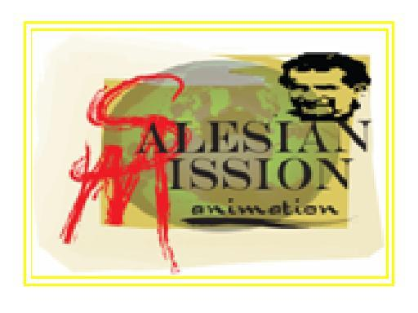

The Formation Kit is an experimental module intended to help in the formation of would-be volunteers and missionaries both in the local and foreign missions. It is primarily intended for young professionals who have the desire to participate in volunteer work as a lay missionary.
It is based on three phases followed successively one after the other. One cannot proceed to the succeeding phases not until each phase has been completed. Every phase has a corresponding module that talks about values and virtues needed in order to discover and inculcate the desire for missionary volunteerism. The following values and virtues had been arrived at as part of the result of the top three resolutions during the 2nd Missionary Symposium of 2006.
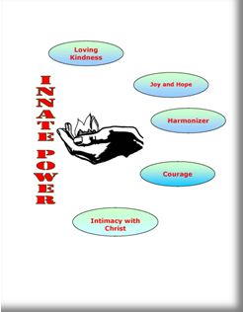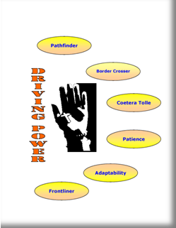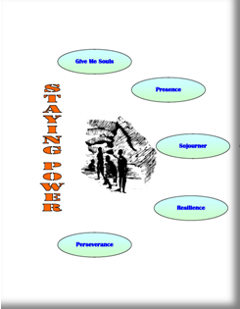

Each module for the three phases is facilitator friendly. The modules are not meant to be taught in one sitting but in a process that will require sufficient time for the young professionals to participate and openly discuss. Hence, the module can be given every time a group meets as a form of reflection guide and inputs.

It is envisioned that the Salesian Missionary Animation Formation Kit can be incorporated in the formation plan especially in Canlubang and the Theologate that can be taught in catechism classes. Likewise, it is suggested that we can join in partnership with the Salesian Lay Volunteers of the Philippines and the Yuppeace where the formation kit can be introduced and included in their activities.

At present, the Formation Kit is further being improved and being given to formators, psychologists and missionaries to be able to get feedbacks and necessary additional ideas and suggestions. Another module of the Formation Kit is being prepared intended for the Fourth Year high school students who would want to explore what volunteerism is all about.

Thank you very much!

